AA502 – Time Series
Homework 1

You have been hired to study foreign exchange rates between the United States and Japan. The provided data set contains only two variables:
Date Monthly date between 01/2000 and 01/2009
Value Japanese Yen to One US Dollar Exchange Rate
Import this data into SAS and develop a report that contains the following points:
- Plot the data series (include the plot in your report) and describe any characteristics you notice about the series.
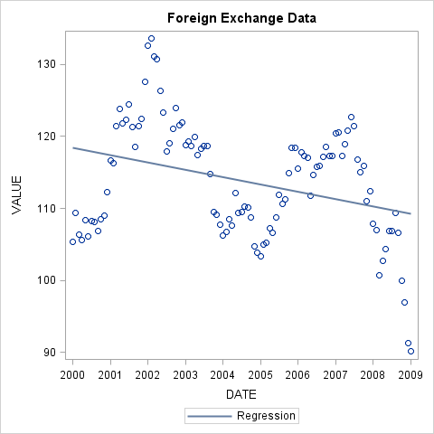
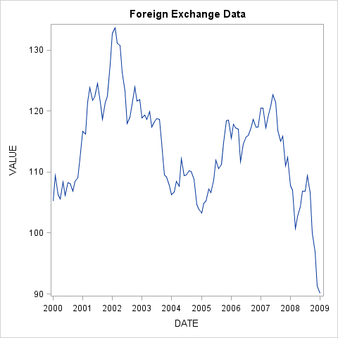
There definitely appears to be a cyclical pattern.
- Plot the ACF, PACF, and IACF (include the plots in your report) and describe any characteristics/interpretations that you notice about these plots.
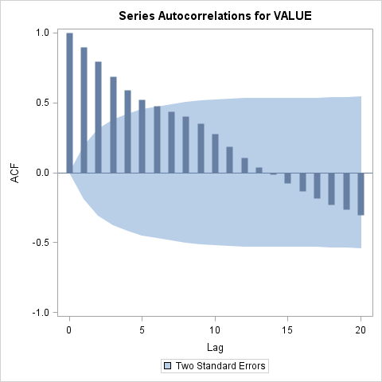
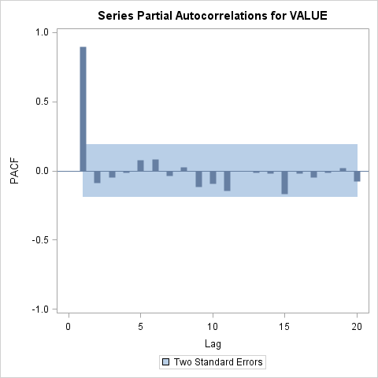
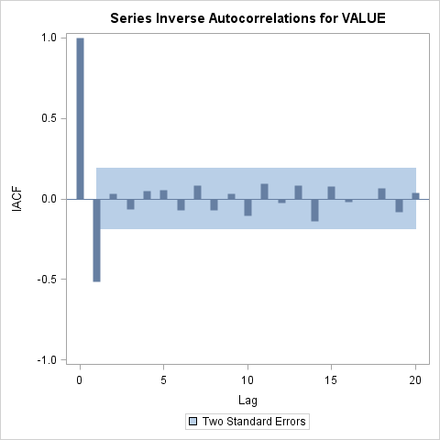
The lags appear to affect future day values.
List the first two values (lags 1 and 2) of the autocorrelation function and interpret their meaning.
1. 0.89991
2. 0.79306
Day 2 has a .79 correlation between day 2 and day 1.
- List the first value (lag 1) of the partial autocorrelation function and interpret its meaning.
1. 0.89991 – Same as autocorrelation. The difference is when you test the lag with more than 1 day. Then the values test to see the relationship between the days while factoring out the days in between.
- Check to see if the data itself is white noise using an official test. Create a plot that shows this characteristic and summarize what you find.
Maximum Likelihood Estimation
Parameter | Estimate | Standard Error | t Value | Approx  Pr > |t| | Lag
MU | 113.81549 | 0.77131 | 147.56 | <.0001 | 0

There is not white noise (yet). The variation in the model can still be modeled.

